油耗与重量关系研究

描述变量
变量名 | 类型 | 格式 | 值标签 | 标签
油耗 | float | %9.0g |  | 油量消耗(公升每一百公里)
重量 | float | %8.0gc |  | 重量(公斤)

摘要统计
变量 | 观测 | 均值 | 标准差 | 最小值 | 最大值
油耗 | 74 | 5.019 | 1.28 | 2.439 | 8.333
重量 | 74 | 1370 | 352.5 | 798.3 | 2195

变量重量的最小值798.32,最大值2195.39,极差1397.06.

图: 油耗与重量
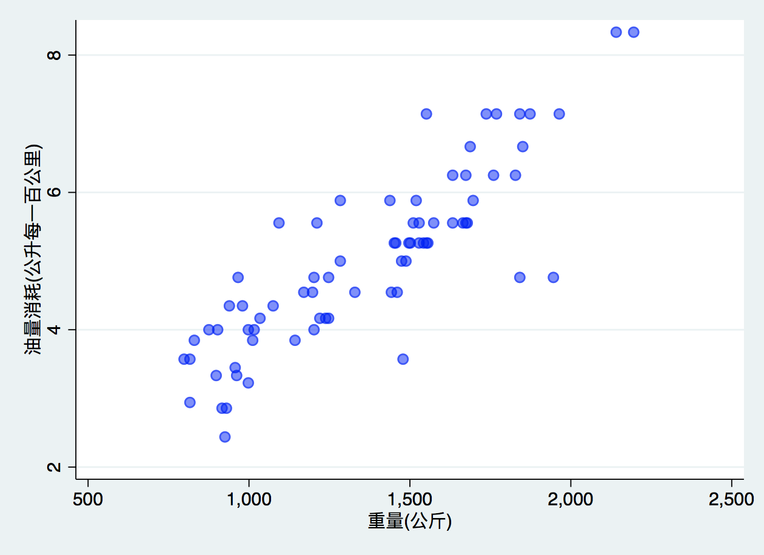
图1: 油耗与重量

研究油耗与重量关系 - 线性回归
油耗 | Coef. | Std. Err. | t | P>|t| | [95% Conf. Interval]
重量 | .003102 | .0002223 | 13.95 | 0.000 | .0026589 | .0035452
_cons | .7707669 | .3142571 | 2.45 | 0.017 | .1443069 | 1.397227

线性回归结果显示重量每增加一百公斤,每百公里油耗增加.31公升。

用-estimates table-对比线性回归结果
 | 模型1 | 模型2
重量(公斤) | 0.0030*** | 0.0028***
变速比 | 0.1706 | -0.3367
转弯半径(米) | 0.0798 | 0.2010
国籍 |  | 0.8650***
Constant | -0.5814 | -0.4661
N | 74 | 74
r2 | 0.7332 | 0.7767
r2_a | 0.7218 | 0.7637

Produce a table from community-contributed -esttab-
用-esttab-对比线性回归结果
线性回归表使用esttab
 | 油耗 | 油耗
 | b/t | b/t
重量(公斤) | 0.003*** | 0.003***
 | (6.09) | (6.06)
变速比 | 0.171 | -0.337
 | (0.64) | (-1.19)
转弯半径(米) | 0.080 | 0.201
 | (0.70) | (1.81)
国籍 |  | 0.865***
 |  | (3.66)
Constant | -0.581 | -0.466
 | (-0.38) | (-0.33)
Observations | 74 | 74
R-squared | 0.73 | 0.78
Adjusted R-squared | 0.72 | 0.76
t statistics in parentheses
* p<0.05, ** p<0.01, *** p<0.001

不同国籍车辆对比
国外 | 国内
观测 均值 标准差 最小值 最大值  油耗 22 4.313 1.144 2.439 7.143  重量 22 1050 196.4 798.3 1551 | 观测 均值 标准差 最小值 最大值  52 5.318 1.224 2.941 8.333  52 1505 315.4 816.5 2195
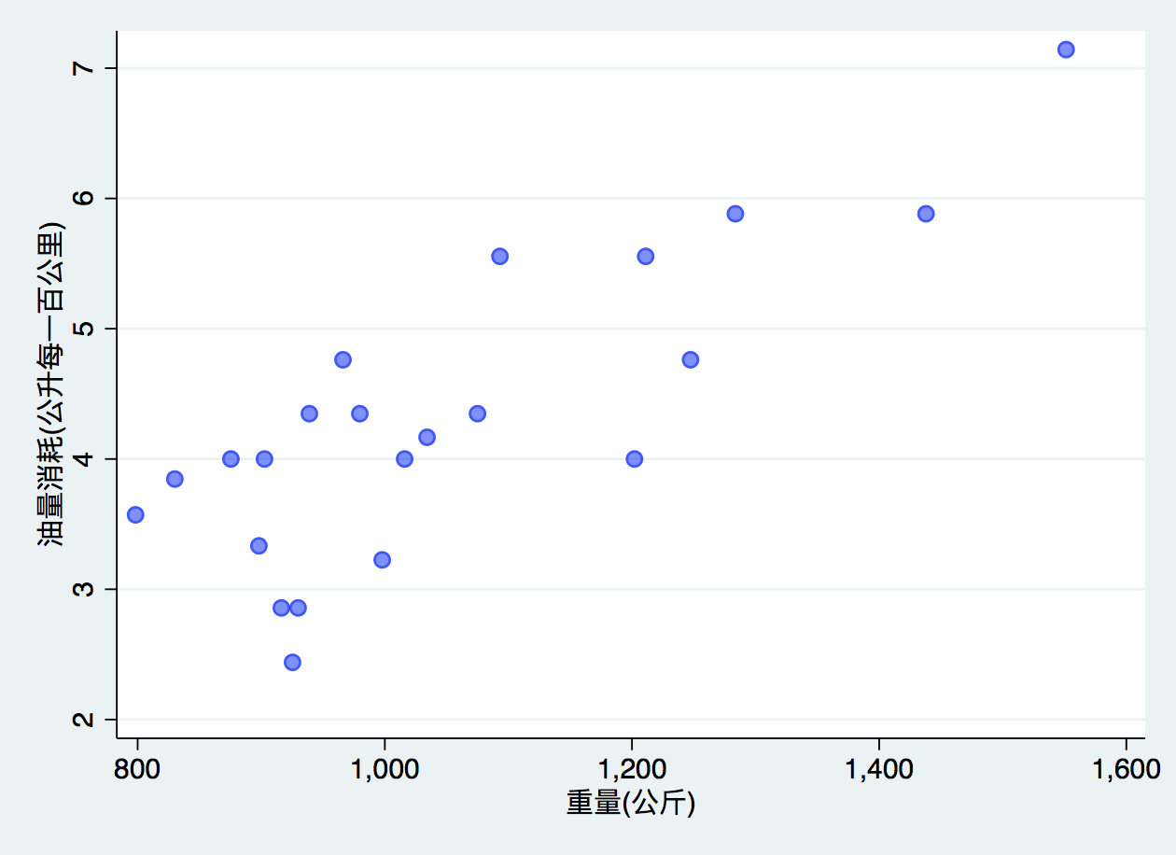 | 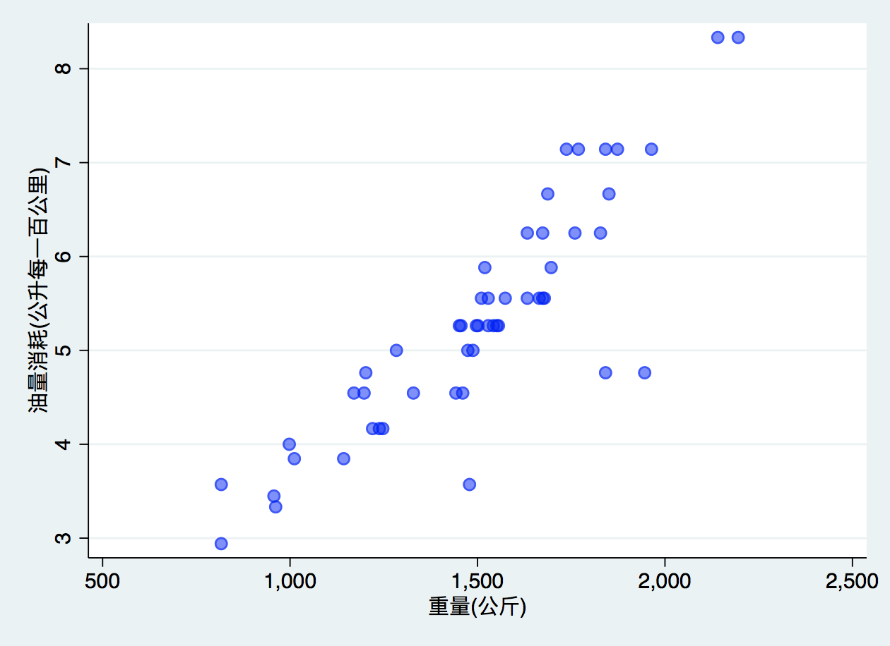
 | b | t | b | t
重量(公斤) | 0.003** | (3.49) | 0.003*** | (5.07)
变速比 | -0.577 | (-1.12) | -0.234 | (-0.72)
转弯半径(米) | 0.672 | (1.67) | 0.217 | (1.92)
Constant | -4.478 | (-1.00) | -0.640 | (-0.43)
Observations | 22 |  | 52
R-squared | 0.73 |  | 0.78
Adjusted R-squared | 0.69 |  | 0.77

Stata命令输出
. use auto_zh, clear
(1978年汽车数据)
. regress 油耗 重量
Source | SS df MS Number of obs = 74
-------------+---------------------------------- F(1, 72) = 194.71
Model | 87.2964971 1 87.2964971 Prob > F = 0.0000
Residual | 32.2797637 72 .448330051 R-squared = 0.7300
-------------+---------------------------------- Adj R-squared = 0.7263
Total | 119.576261 73 1.63803097 Root MSE = .66957
------------------------------------------------------------------------------
油耗 | Coef. Std. Err. t P>|t| [95% Conf. Interval]
-------------+----------------------------------------------------------------
重量 | .003102 .0002223 13.95 0.000 .0026589 .0035452
_cons | .7707669 .3142571 2.45 0.017 .1443069 1.397227
------------------------------------------------------------------------------
. mata:
------------------------------------------------- mata (type end to exit) ------
: st_view(Y=.,.,("油耗"), .)
: st_view(X=.,.,("重量"), .)
: X=X,J(rows(X),1,1)
: b=invsym(X'*X)*X'*Y
: v=((Y- X*b)'*(Y- X*b))/(rows(X)-cols(X))*invsym(X'*X)
: se=sqrt(diagonal(v))
: t=b:/se
: p=2*ttail(rows(X)-cols(X),abs(t))
: b,se,t,p
1 2 3 4
+---------------------------------------------------------+
1 | .0031020043 .0002223018 13.95402458 3.66622e-22 |
2 | .7707668702 .3142570686 2.45266359 .0166043065 |
+---------------------------------------------------------+
: end
--------------------------------------------------------------------------------

