. sysuse auto, clear
. summarize mpg
We can easily add Stata results (mpg total= 1576.00).
We can add formatted text to a table cell.
italicize, strikeout, underline, sub/super script² , and shade the text. Stata results too (mpg total = 1576.00)

We can easily add estimation table using etable.
. regress mpg foreign weight headroom trunk length turn displacement
mpg | Coef. | Std. Err. | t | P>|t| | [95% Conf. Interval]
foreign | -1.966646 | 1.181383 | -1.66 | 0.101 | -4.325355 | .3920619
weight | -.0041958 | .002022 | -2.08 | 0.042 | -.0082328 | -.0001588
headroom | -.0591903 | .6449333 | -0.09 | 0.927 | -1.346841 | 1.228461
trunk | -.012178 | .1589785 | -0.08 | 0.939 | -.3295888 | .3052327
length | -.0631178 | .0643524 | -0.98 | 0.330 | -.1916014 | .0653659
turn | -.1648614 | .1980936 | -0.83 | 0.408 | -.560368 | .2306451
displacement | .0007923 | .0102838 | 0.08 | 0.939 | -.0197399 | .0213246
_cons | 53.1377 | 7.583645 | 7.01 | 0.000 | 37.99647 | 68.27894

. estimates table
Variable | m1 | m2
gear_ratio | 3.033 | 1.357
 | 1.373 | 1.290
turn | -0.733 | -0.122
 | 0.142 | 0.191
length |  | -0.167
 |  | 0.039
_cons | 41.218 | 53.349
 | 8.991 | 8.531
N | 74 | 74
r2_a | 0.536 | 0.628

We can put graphs in table cells.
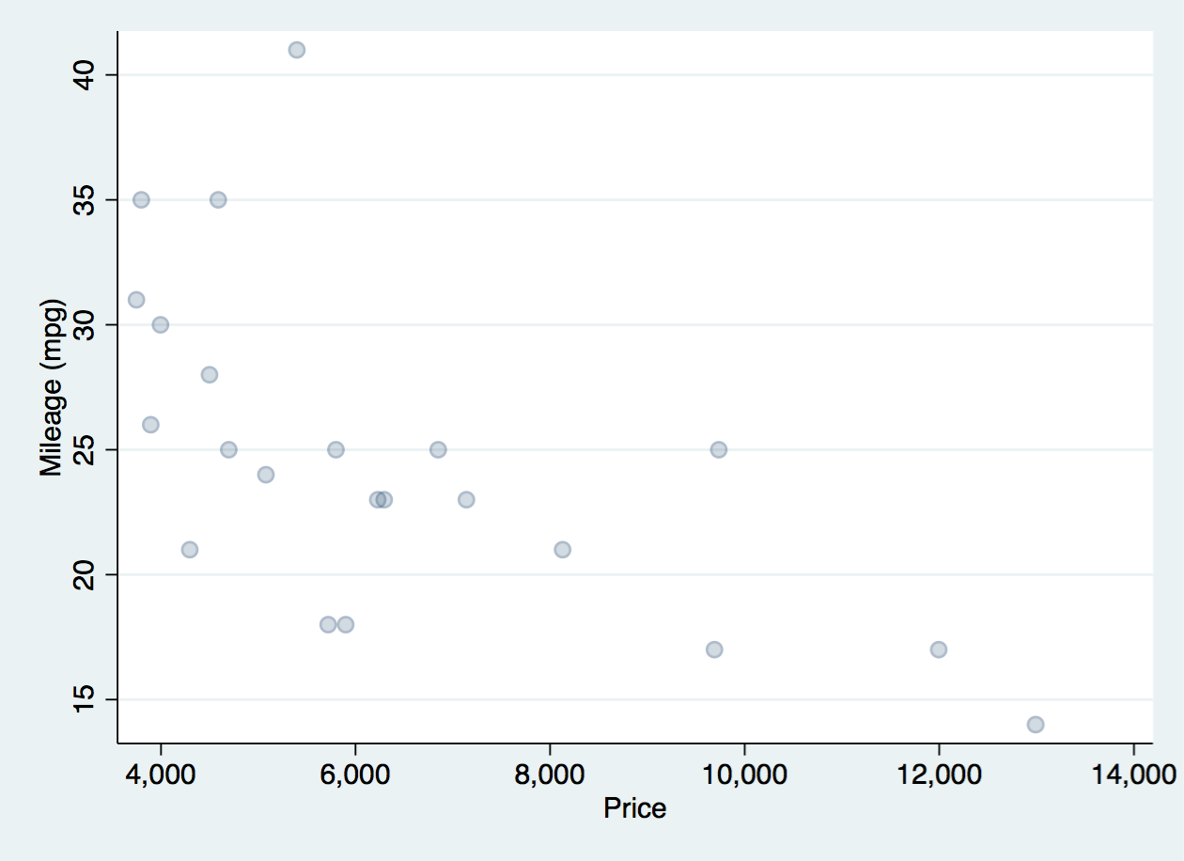Foreign | 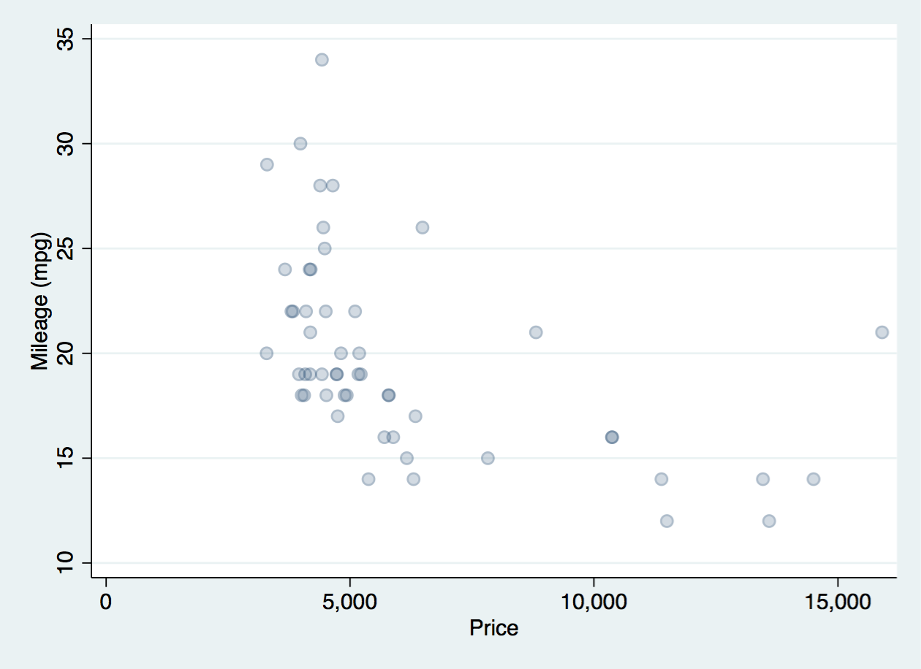 Domestic
Scatter plot: mpg price

