A quick study of auto dataset
We will use the auto dataset. It includes variable price:
. sysuse auto, clear
(1978 Automobile Data)
. summarize price
Variable | Obs Mean Std. Dev. Min Max
-------------+---------------------------------------------------------
price | 74 6165.257 2949.496 3291 15906
The mean of price is 6165.257. We will also check the relationship between mpg and weight visually.
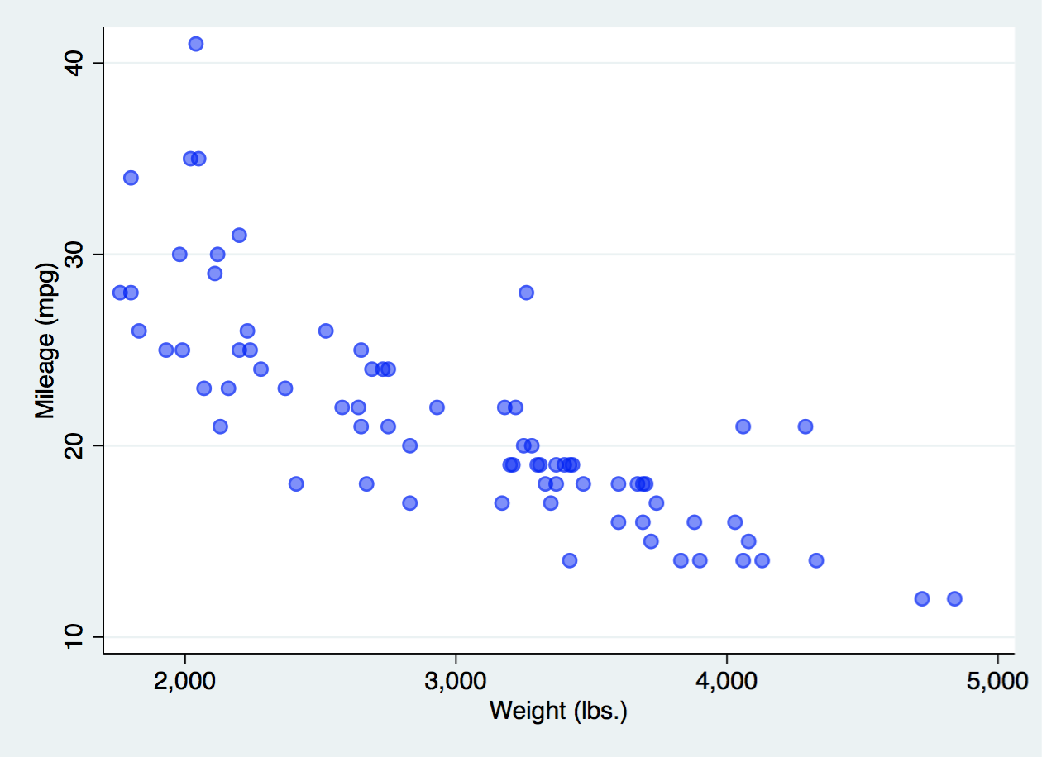
and via a linear regression:
. regress mpg weight
Source | SS df MS Number of obs = 74
-------------+---------------------------------- F(1, 72) = 134.62
Model | 1591.9902 1 1591.9902 Prob > F = 0.0000
Residual | 851.469256 72 11.8259619 R-squared = 0.6515
-------------+---------------------------------- Adj R-squared = 0.6467
Total | 2443.45946 73 33.4720474 Root MSE = 3.4389
------------------------------------------------------------------------------
mpg | Coef. Std. Err. t P>|t| [95% Conf. Interval]
-------------+----------------------------------------------------------------
weight | -.0060087 .0005179 -11.60 0.000 -.0070411 -.0049763
_cons | 39.44028 1.614003 24.44 0.000 36.22283 42.65774
------------------------------------------------------------------------------

