A fuel consumption study of Stata's auto dataset
We conduct a study of the fuel consumption of cars in Stata's auto dataset.

Perform data transformation
We generate a variable, fuel, in the unit of Gallons per 100 Miles based on the variable mpg.
. generate fuel = 100/mpg
. label variable fuel "Fuel consumption (Gallons per 100 Miles)"

Examine the variables
We examine variables for possible errors in the data.

Describe the variables
Name | Storage type | Display format | Value label | Variable label
fuel | float | %9.0g |  | Fuel consumption (Gallons per 100 Miles)
weight | int | %8.0gc |  | Weight (lbs.)

Summarize the variables
Variable | Observations | Mean | Standard Deviation | Min | Max
fuel | 74 | 5.019 | 1.28 | 2.439 | 8.333
weight | 74 | 3019 | 777.2 | 1760 | 4840

The variable weight has minimum value 1760.00, maximum value 4840.00, and range 3080.00.

Plot fuel consumption and vehicle weight
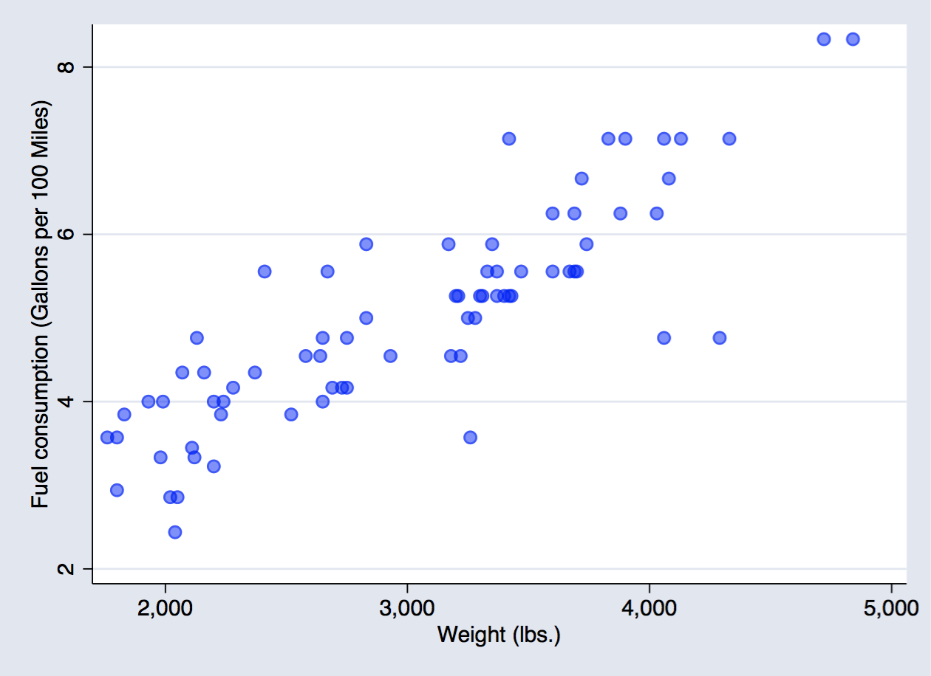
Figure 1: scatter plot fuel consumption and weight

Explore relationship between fuel consumption and vehicle weight - linear regression
fuel | Coef. | Std. Err. | t | P>|t| | [95% Conf. Interval]
weight | .001407 | .0001008 | 13.95 | 0.000 | .001206 | .0016081
_cons | .7707669 | .3142571 | 2.45 | 0.017 | .1443069 | 1.397227

The regression shows that for every unit increase in weight, a 0.0014 unit increase in fuel consumption is predicted.

Produce a table from -estimates table-
We list the results from two regressions.
Variable | model1 | model2
Weight (lbs.) | 0.0014*** | 0.0013***
Gear Ratio | 0.1706 | -0.3367
Turn Circle (ft.) | 0.0243 | 0.0613
Car type |  | 0.8650***
Constant | -0.5814 | -0.4661
N | 74 | 74
r2 | 0.7332 | 0.7767
r2_a | 0.7218 | 0.7637

Produce a table from community-contributed -esttab-
We list the results from the same two regressions as above using -esttab- and -putdocx-. -esttab- is a popular community-contributed command which generates tables for report.
Regression table using -esttab-
 | Fuel consumption | Fuel consumption
 | b/t | b/t
Weight (lbs.) | 0.001*** | 0.001***
 | (6.09) | (6.06)
Gear Ratio | 0.171 | -0.337
 | (0.64) | (-1.19)
Turn Circle (ft.) | 0.024 | 0.061
 | (0.70) | (1.81)
Car type |  | 0.865***
 |  | (3.66)
Constant | -0.581 | -0.466
 | (-0.38) | (-0.33)
Observations | 74 | 74
R-squared | 0.73 | 0.78
Adjusted R-squared | 0.72 | 0.76
t statistics in parentheses
* p<0.05, ** p<0.01, *** p<0.001

Relationship based on car type - a nested table
Foreign | Domestic
Observations Mean Standard Deviation Min Max  fuel 22 4.313 1.144 2.439 7.143  weight 22 2316 433 1760 3420 | Observations Mean Standard Deviation Min Max  52 5.318 1.224 2.941 8.333  52 3317 695.4 1800 4840
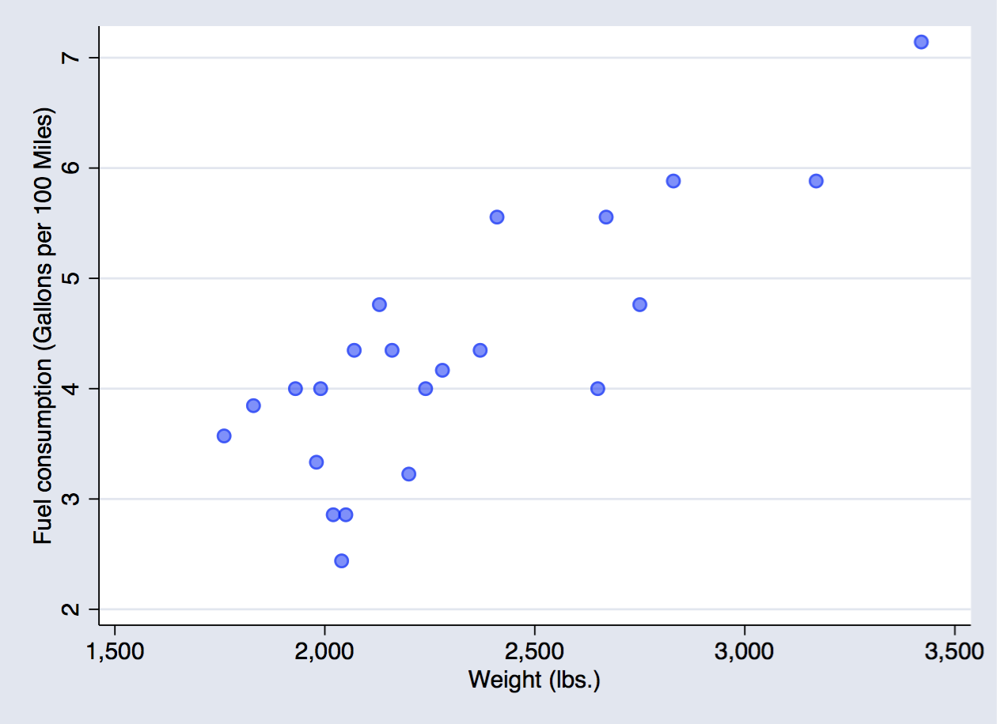 | 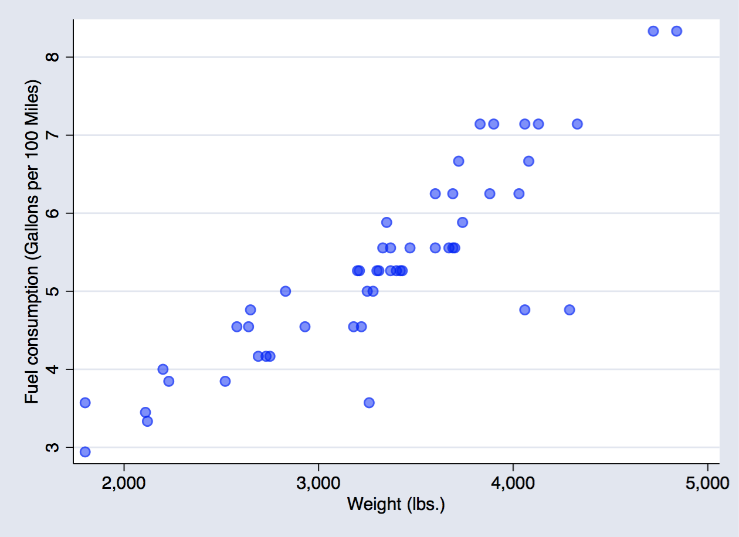
 | b | t | b | t
Weight (lbs.) | 0.002** | (3.49) | 0.001*** | (5.07)
Gear Ratio | -0.577 | (-1.12) | -0.234 | (-0.72)
Turn Circle (ft.) | 0.205 | (1.67) | 0.066 | (1.92)
Constant | -4.478 | (-1.00) | -0.640 | (-0.43)
Observations | 22 |  | 52
R-squared | 0.73 |  | 0.78
Adjusted R-squared | 0.69 |  | 0.77

